determination redox potential (Eh) by Depolarization curve method
Fang Jianan
Nanjing Zhuan-Di Instrument & Equipment CO., LTD.
Academia Sinica Nanjing research institute of Soil technical service center
1. outline
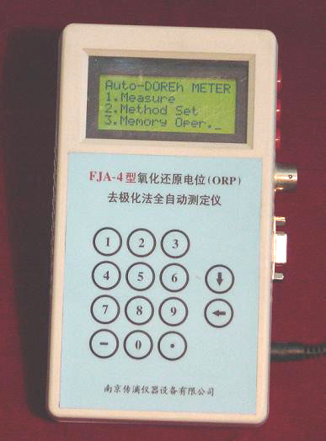
The redox potential (Eh) took the medium (including soil, natural water, culture medium and so on) an environmental condition comprehensive target, has continued to use very for a long time, it attributes the medium oxid ability or the reducible relative degree. The since long ago redox potential is uses the platinum electrode direct measuring method (two electrodes method). Namely the platinum electrode and the reference electrode are direct insertion medium in to determine. But when determines the weak balance system (poising), as a result of the platinum electrode by no means absolute inertia, its surface may form the oxide film or adsorb other matter. Affects each oxidation reduction electricity to on the platinum electrode electronic exchange speed, therefore the equilibriumpotential establishment is extremely slow, in some medium must after several hours even one, two days. Commonly used is direct potentionmetric balances (read time which 2 minutes generally uses) with to balance for 1 hour, determines the electric potential value difference may not be very same, generally misses 20-40mV. Decomposes in theexuberant situation in the organic matter, even reaches above 100mV, therefore in application determination data time, must explain the reading the time. If fully had considered the platinum electrode surface properties and the electrode potential establishment dynamics process, to the complex medium, has used the depolarization curve method determination redox potential. May obtain a more precise final outcome in a shorter time, obtains the balance Eh value with the depolarization curve method after is direct measuring method balances the stable Eh value which 48 hours obtains, the difference generally is smaller than 10mV. Therefore the depolarization curve method can reduce the survey time, and has the higher determination precision. However in analysis process operation anxious, mathematics processing is arduous. But we develop and production FJA-3, the FJA-4 oxidation reduction potential (Eh) the depolarization curve method automatic cryoscope, completely automatic on the control, the survey, the data processing, the Depolarization curve and the determination result can save the hard disk and soon. Increases the determination precision and the working efficiency,reduced the labor intensity. In order to determine Eh to provide one kind of new instrument.
2． measuring principles
Connect the polarizing voltage to the platinum electrode (polarizing voltage is 600 -750mV), by the silver - silver chloride electrode took the auxiliary electrode, receives the power source the negative end, above the anodic polarization 10 seconds (free choice).Then shuts off polarizes the power source, Carries on the depolarization, the time (regards polarization curve above 20 seconds to decide), monitors the platinum electrode after the depolarization the electric potential (to calomel electrode), regarding the majority test sample, electrode potential E (millivolt) and depolarization time logarithm logt has the linear relation. Carries on the cathode polarization and the afterwards depolarization and the monitor electric potential by the same method. The anode depolarization curve and the negative depolarization curve extends the long-line point of intersection to be equal to the equilibrium potential. Two curves equations are:
E _{anode} =a1+b1logt _{anode}
E _{negative} =a2+b2logt _{negative}
Solves this two straight lines equation to be possible to obtain the equilibrium potential formula
E= (a₂b₁-a₁b₂)/(b₁-b₂)
The equilibrium potential adds the electric potential value of calomel electrode on under this temperature, then extracts the Eh value.
3． Eh depolarization method automatic determination
Commonly used is direct measuring method is two electrodes measured system (platinum electrode and saturated calomel electrode), The Eh depolarization curve method automatic cryoscope is four electrodes systems (platinum electrode, saturated calomel electrode, silver -silver chloride electrode and temperature sensor).
FJA-3, the FJA-4 determination redox potential (Eh) by Depolarization curve method automatic cryoscope, by a small hardware part, the electrode system, PC (or portable computer) and the application software is composed. It may make Eh the single survey, also may carry on the circulation data acquisition; May apply in the room, also may in the open country application. FJA-3, the FJA-4 redox potential(Eh) the Depolarization curve method automatic cryoscope function is the entire automatic control, the survey and the data processing, is concrete is:
1) automatic control polarization time.
2)automatic control depolarizations time.
3) automatic gathering data.
4)automatic Transformation polarities.
5)automatic temperature compensation to calomel electrodes potential .
6)automatically carries on the data processing.
7)the automatic plan curve and will be automaticfinally saves the Hard disk.
4. determinations results
Before the determination, first establishes the parameter in the menu, like tests the person name, once or circulates,equi-potentiality gathering or instantaneous gathering, the polarized time, the depolarization time, the gathering data points and the time interval and so on. Then the input sample number may carry on the automatic survey.

The number of times | 1 | 2 | 3 | 4 | 5 | 6 | 7 | mean values E | standard misses | Scoefficientof variation CV (%)
result | 538.3 | 535.4 | 538.1 | 537.8 | 536.1 | 534.4 | 538.4 | 536.93 | 1.599 | 0.298
Temperature | 15.00 | 14.97 | 14.96 | 14.91 | 14.84 | 14.84 | 14.83 | 14.91 | 0.507 | 3.4

May see from table, the Depolarization curve method surveys Eh, reappears to be good, error in 10mV.

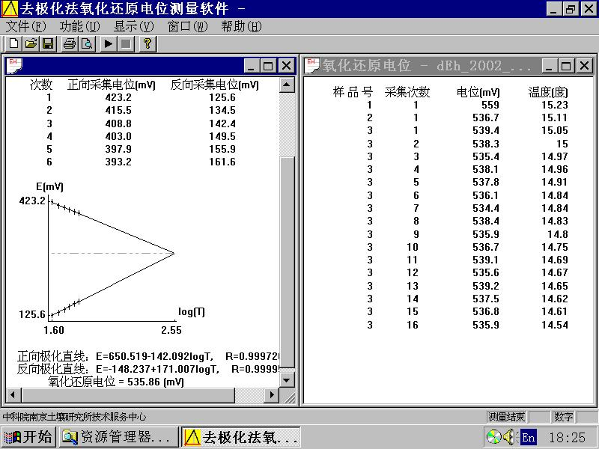

Reference
(1) Liu, Z.G.and Yu, T.r. (1,984) J.Siol Sci.,35: 469.
(2) Fang Jianan, Liu Zhiguang analyzes instrument, 1,987,(1), 23.
(3)Fang Jianan, Xia Quan electro-chemistry analysis instrument, south east university publishing house, in 1992.

